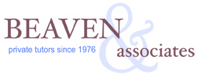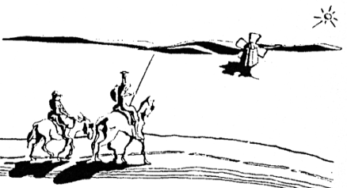
Beaven & Associates, through its Passport Exchange program, brings students from Europe to the Andover and New England area in the summer for a four week program that features a host family stay.
Application
Name:
School and Grade:
Parents’ Home Phone: Parents’ Cell Phone:
Parents’ Email
Parents’ Address:
Parents’ Occupation:
How many years of English have you studied in school?
Please list any allergies to pets, food, or pollen.
Please write below a description of what you might hope to gain from and what you might hope to bring to the experience of living as a guest for four weeks in an American family.
Please write below a description of what you most enjoy doing in your leisure time. You may list various activities and you could mention your favorite books, movies and subjects in school.
Please submit a recent photo of the student with this application.

Please return this completed application and photo by email to info@beavenandassociates.com
or by standard mail to: Beaven & Associates, 3 Dundee Park Suite 202A, Andover, MA 01810, USA

