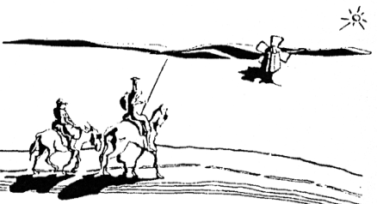 Passport Exchange: Summer Homestay in the U.S.

The best way for an American to begin to learn about a foreign country is to host a student from that country. The best way for a visitor to the United States to get to know America, its people, and the English language is as a guest of a host family in our exchange program. Since 1979, Passport Exchange has introduced international students to the homes and communities of American families, and in doing so, encouraged students from Europe and the United States to establish bonds of friendship and understanding while improving foreign language skills and cultural awareness. Many of our families who hosted students in the past have been hosted in the country and family of their former guest.

Who Participates?

 Students from Spain and Italy between the ages of ten to nineteen
 Most have an intermediate level of spoken English
 All students are screened abroad for individual interests and preferences and matched with a compatible American family

Host Families:

 Host families need to provide a warm, friendly home with an extra bed. This bed need not be in a separate room. Your European student will enjoy sharing space and facilities with your own children. Interaction between family members is an important part of the exchange.
 All prospective host families will be interviewed to determine a suitable match and to be given an orientation as to how the program works.

Two Programs From Which to Choose:

Discover Boston
Our local Andover based program is for families in which both parents work and who live within a commuting distance of Andover. During the weekdays from nine to five, our agency, headquartered at Building 3 Dundee Park in Andover, will provide the exchange student a summer camp experience of tutorials, activities, and excursions. Family members may join their gusts during the weekdays for the activities and for excursions, many of which take the students on chaperoned explorations of Boston.

Families in New England
In this program, a parent needs to be at home throughout the visit of the exchange student so as to be able to introduce the student to friends, neighbors, and relatives, as well as to offer the guest opportunities for recreation and leisure. The family would thus, through its normal activities, incorporate the student into their own routine independent of the Andover-based program. Such families could take their guest with them on day trips, vacations, or to their summer home which could be located anywhere in New England.

Host Family Application

I am interested in hosting a student this summer.

Parent’s Name (please print)

Address City/Town State Zip

Phone (cell) Phone (home) E-mail

Names and ages of children in the home

Interests and hobbies of the family and of the children:

Do you prefer: Male Female No preference

Age range preferred

Please list family pets

Would you prefer to be a host in the Discover Boston program or the Families in New England program?

Would you be interested in having someone in your family hosted in a family in Spain or Italy?

Would you be interested in traveling to Spain or Italy on an educational tour?

Would you be interested in helping Passport Exchange find other host families that would support the program?

Please return this completed application by email to info@beavenandassociates.com
or by standard mail to: Beaven & Associates, 3 Dundee Park Suite 202A, Andover, MA 01810, USA

